Scone Equestrian Vaulting Team Virtual Vaulting Event 2020
This event is NOT a competition and has been organised to promote horse and vaulter fitness and keep our sport moving forward through COVID-19. Entry will provide individuals with feedback on their individual performances.
Requirements for this event will follow the Australian Vaulting Rules (July 2019) but feedback may be limited by footage submitted.
Vaulters may enter up to 2 levels from each category.
Please read carefully the “Conditions and General Information” it is your responsibility to be aware of these as by entering you are agreeing to these terms.
Payment will be via Paypal. Please note there is a small processing fee of 18cents per entry charged by the website. A Credit Card Processing Fee will be applied by Paypal.
All enquiries are to be made via email: sevtemail@icloud.com (Please allow 24 hours for a reply)

BARREL SUBMISSIONS
 | Category 1 : INDIVIDUAL FREESTYLE
1 | OPEN / ADVANCED | $7
2 | INTERMEDIATE | $7
3 | NOVICE | $7
4 | PRE-NOVICE | $7
5 | PRELIMINARY | $7
6 | INTRODUCTORY | $7
7 | “MASTERS” (Lungers, Coaches, Parents, Grandparents, Etc.) | $7
HORSE SUBMISSIONS
 | Category 2 : INDIVIDUAL FREESTLYE
8 | OPEN / ADVANCED | $7
9 | INTERMEDIATE | $7
10 | NOVICE | $7
11 | PRE-NOVICE | $7
12 | PRELIMINARY | $7
13 | INTRODUCTORY | $7
 | Category 3 : INDIVIDUAL COMPULSORIES
14 | OPEN | $7
15 | ADVANCED | $7
16 | INTERMEDIATE / NOVICE | $7
17 | PRE-NOVICE | $7
18 | PRELIMINARY / INTRODUCTORY | $7
 | Category 4 : TECHNICAL TEST
19 | OPEN TECH TEST | $7

EXCLUSIVE SEVT COVID-19 T-SHIRT AVAILABLE VIA THE WEBSITE ONLINE SHOP.
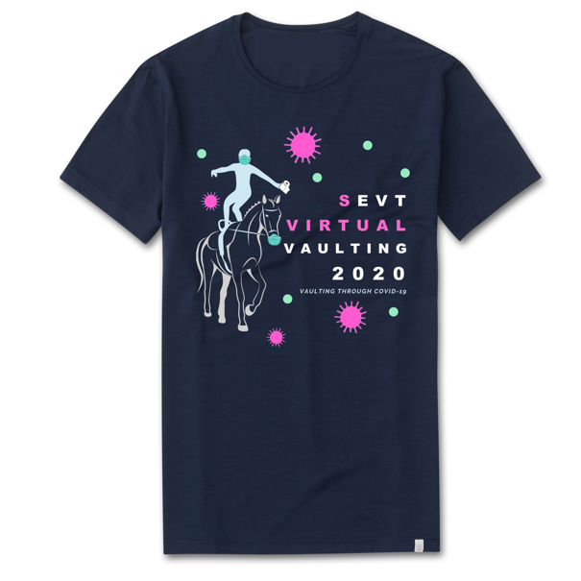
CONDITIONS AND GENERAL INFORMATION
ENTRIES AND FEEDBACK
Scratchings: There will be no refunds processed as this is a low-cost feedback orientated event.
Please ensure you select your class carefully and note that each class will have a unique Dropbox submission link listed on your ticket. Please use this to upload your video by the closing date.
Feedback will be given by applying applicable Australian Vaulting Rules (July 2019) but may be limited by the footage submitted. Participants agree to accept feedback as given and are not to contact the person providing feedback, in relation to this event.
HORSE WELFARE
It is the responsibility of the horse owner/lunger/vaulter to ensure that horses are sound and fit for purpose. Videos submitted for feedback where horse welfare concerns are identified will not receive feedback.
A FULL trot circle MUST be included in all horse class submissions prior to the vaulter mounting.

PRIVACY
We are utilising the following submission portals and as such their privacy links are attached:
- WIX https://www.wix.com/about/privacy
- Dropbox https://www.dropbox.com/en_GB/privacy
- Paypal https://www.paypal.com/au/webapps/mpp/ua/privacy-full
By entering this event you agree that your entry will be stored in a Dropbox which will be accessible by SEVT committee members and will be forwarded to the people providing feedback for review. All submissions will be deleted from the Dropbox folder 6 weeks after closing date. Those providing feedback have agreed not to share footage of vaulters with anyone and have agreed not to keep copies of videos submitted.
Entrants under 18 must gain parental/guardian permission prior to entry.

VIDEO REQUIREMENTS
- All videos submitted must be compatible with Windows Media Player (https://support.microsoft.com/en-au/help/2395168/basics-about-videos-and-video-codecs-in-windows-media-player)
Generally, most video formats can be played using Windows Media Player, but it may be prudent to check and confirm.
- Videos must not be edited (including audio edit), however may be cut to a start and finish time.
- A FULL trot circle MUST be included in all horse class submissions prior to the vaulter mounting.
- Unitards/costumes must be worn
- All video must be shot from a stationary position in good lighting (hint: do not film into the sun)
- Horse submissions should be filmed from a stationary position and from the outside of the circle (note a full trot circle must be included in the continuous footage prior to the vaulter mounting)
- Music should be at a consistent level throughout the footage
- Video must include continuous footage of either the Vaulter & Barrel/Horse
SUBMISSION PROCESS OVERVIEW

